Employee Task Tracker Application

Introduction
The Employee Task Tracker Application is built using Microsoft Power Apps with Power Automate integration.
This application helps employees record daily tasks and working hours, while providing managers with visibility into employee productivity through a dedicated manager view and automated email alerts.
System Overview
Technologies Used
- Microsoft Power Apps
- Microsoft Power Automate
- Excel / SharePoint / Dataverse (as backend data source)
User Roles
- Employee
- Manager
Employee Role – Application Usage

Individual Tracker Screen
Description:
When an employee opens the application, the system automatically identifies the logged-in user and displays the Employee Dashboard.
Key Functions:
- Displays employee name automatically
- Allows adding new tasks
- Displays current task status

Adding a New Task

- Click on Add New Task
- Enter task details
- Save the task
Result:
The task is created and displayed on the dashboard.
Task Status Management
Employees can update the task status throughout the day.
Available Task Statuses:
- In Progress – When the task is actively worked on
- Break – When the employee goes on break
- Completed – When the task is finished
All status changes are saved automatically.
Task Status Management
Employees can update the task status throughout the day.
Available Task Statuses:
- In Progress – When the task is actively worked on
- Break – When the employee goes on break
- Completed – When the task is finished
All status changes are saved automatically.
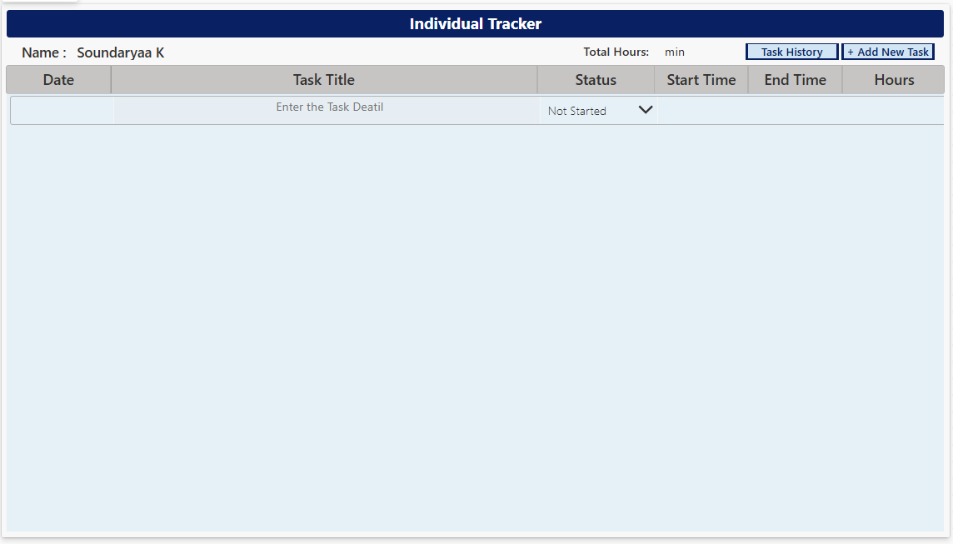
Task History View Screen
Description:
The Task History view allows employees to review previously completed tasks, including tasks from earlier days.
Key Benefits:
- Transparency of work history
- Easy reference for completed tasks
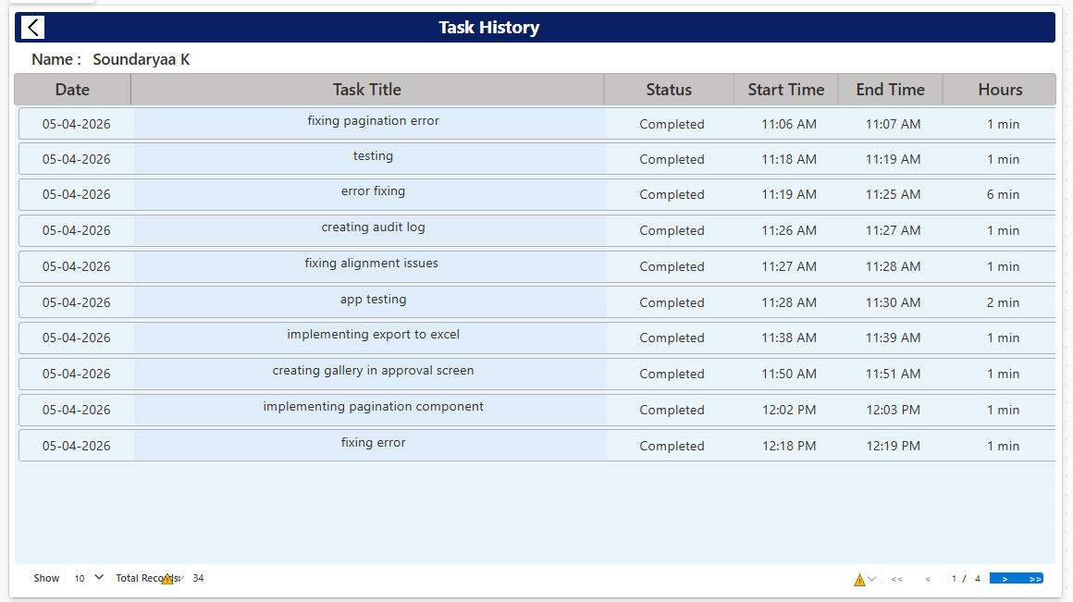
Manager Role – Application Usage

Manager View Access
The Manager View is restricted and available only to users whose email IDs are configured as managers.

Security Note:
Normal employees cannot access this screen.

Manager View Screen

Description:
This screen displays an overview of all employees.

Details Displayed:
- Employee ID
- Employee Name
- Department
- Total Working Hours

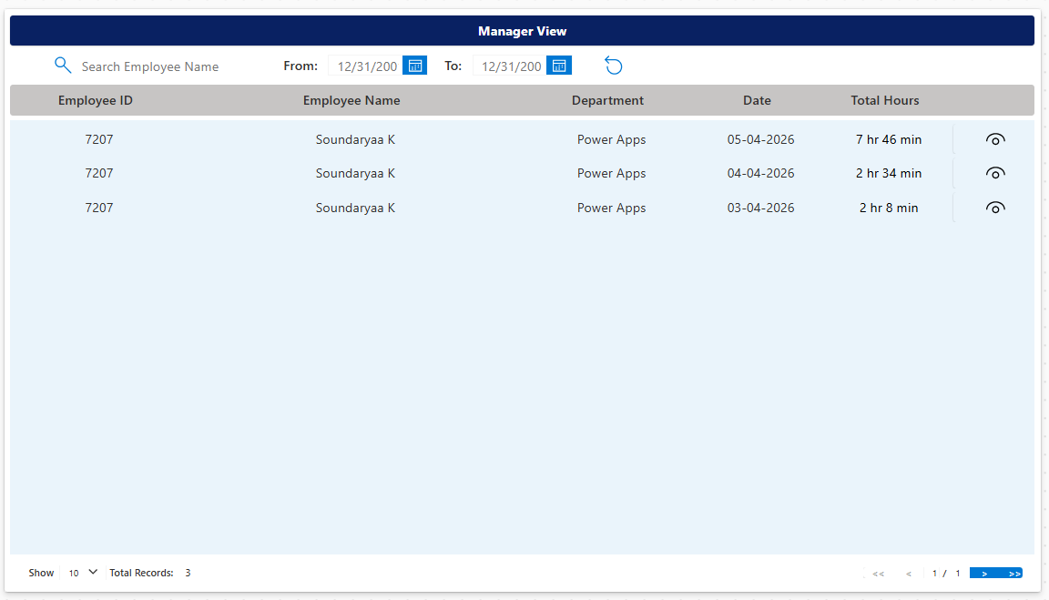

View List Screen

Managers can click the View option next to an employee to see detailed task information.

Information Available:
- Task names
- Task duration
- Task status history

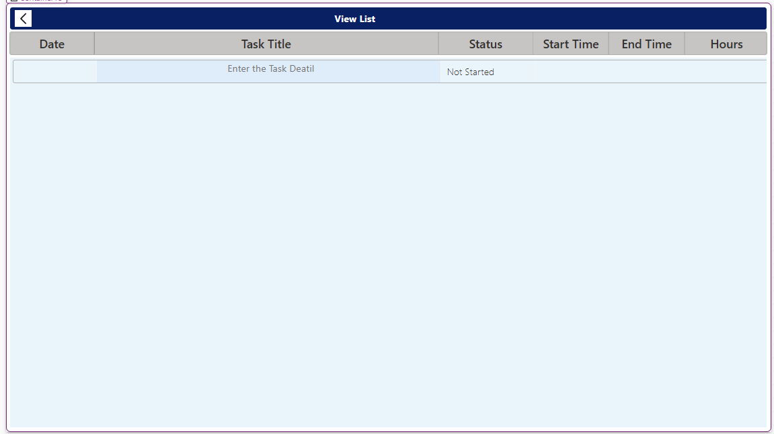

Conclusion

The Employee Task Tracker Application provides an end-to-end solution for tracking employee productivity, managing daily tasks, and ensuring accountability through automated monitoring and alerts.
This user manual explains the complete application flow for both employees and managers.

